Emerging Technology Adoption Readiness Assessment
DCIT 26 – Application Development and Emerging Technologies

Manila Manufacturing Corporation (MMC)
Interview Guide

Prepared by:
Justimbaste, Gerome Eujuan B.

Section: ________________________________
Instructor: ______________________________
Date: ___________________________________

INTERVIEW GUIDE
Organization: Manila Manufacturing Corporation (MMC)
Consultant: TechVision Consulting Inc.
- Interviewer Instructions
Purpose of the Interview
The purpose of this interview is to gain insights into the current operations of Manila Manufacturing Corporation and to identify the challenges it is currently experiencing. The information gathered will serve as the basis for developing a technology adoption recommendation for MMC.
Interviewer Instructions
- Introduce yourself and explain the purpose of the interview.
- Explain that the questions focus on MMC’s current operations and use of emerging technologies.
- Record responses and examples.
- Ask probes with “Why?” ”How?” and “Can you elaborate?” if needed.
- Avoid directing the interviewee toward a specific technology.
- Thank the interviewee for their time and participation.

- Interviewee Information
Name: __________________________________________________________________________________
Position/Role: ___________________________________________________________________________
Department: _____________________________________________________________________________
Years with MMC: _________________________________________________________________________
Date of Interview: ________________________________________________________________________
Interviewer: _____________________________________________________________________________

- Interview Proper
- Background and Current State
Q1. Can you briefly explain how the manufacturing process currently works at MMC?
Response/Notes:
________________________________________________________________________________________
________________________________________________________________________________________
________________________________________________________________________________________
Follow-up question: Which of the processes takes the most time?
Q2. What common problems does MMC experience during its daily operations?
Response/Notes:
________________________________________________________________________________________
________________________________________________________________________________________
________________________________________________________________________________________
Follow-up question: What do you think caused these?
Q3. What computer systems or other technology does MMC use in its operations?
Response/Notes:
________________________________________________________________________________________
________________________________________________________________________________________
________________________________________________________________________________________
Q4. How does MMC collect, manage production, and business data?
Response/Notes:
________________________________________________________________________________________
________________________________________________________________________________________
________________________________________________________________________________________
Follow-up question: Does MMC undergo any problems in managing and using its data?
Q5. If there's a chance to enhance MMC's operations, what would you enhance? Response/Notes:
________________________________________________________________________________________
________________________________________________________________________________________
________________________________________________________________________________________
Follow-up question: Why would you think that it needs improvement?

- Technology Awareness and Readiness
Q6. How would you elaborate on your understanding of its five characteristics?
Follow-up question: Can you explain how these characteristics could be applied in MMC? Response/Notes:
________________________________________________________________________________________
________________________________________________________________________________________
________________________________________________________________________________________
Q7. Has MMC ever discussed using any of these?
Follow-up question: Which technology was discussed, and what was the purpose?
Response/Notes:
________________________________________________________________________________________
________________________________________________________________________________________
________________________________________________________________________________________
Q8. Based on MMC's situation, how ready is your company to adopt new technology?
Follow-up question: What makes you think MMC is ready or not ready?
Response/Notes:
________________________________________________________________________________________
________________________________________________________________________________________
________________________________________________________________________________________
Q9. What would encourage MMC to consider using a new technology?Response/Notes:
________________________________________________________________________________________
________________________________________________________________________________________
________________________________________________________________________________________
Q10. What might make MMC hesitate to adopt new technology?
Response/Notes:
________________________________________________________________________________________
________________________________________________________________________________________
________________________________________________________________________________________ Follow-up question: Why do you think MMC might be hesitant?

- Industry and Competitive Analysis
Q11. How do you think emerging technologies could affect the manufacturing industry in the coming years?
Response/Notes:
________________________________________________________________________________________
________________________________________________________________________________________
________________________________________________________________________________________
Follow-up question: What difficulties does your MMC experience because of these?

Q12. What benefits do you think companies can get from these?
Follow-up question: Can you give an example?
Response/Notes:
________________________________________________________________________________________
________________________________________________________________________________________
________________________________________________________________________________________
Q13. How important do you think it is for MMC to keep up with the new technologies being used by other companies?
Response/Notes:
________________________________________________________________________________________
________________________________________________________________________________________
________________________________________________________________________________________
Q14. Where do you think technology could give MMC an advantage over its competitors?
Response/Notes:
________________________________________________________________________________________
________________________________________________________________________________________
________________________________________________________________________________________

- Specific Technology Area
Artificial Intelligence (AI)
Q15. Artificial Intelligence, or AI, allows machines or systems to perform tasks that normally require human thinking. Where do you think AI could be useful in MMC's operations?
Response/Notes:
________________________________________________________________________________________
________________________________________________________________________________________
________________________________________________________________________________________
Follow-up question: Can you give an example of a task or problem where AI could help?

Machine Learning
Q16. Learning from experiences is what an Machine do. How useful do you think Machine Learning is? Response/Notes:
________________________________________________________________________________________
________________________________________________________________________________________
________________________________________________________________________________________

Augmented Reality (AR)
Q17. AR adds digital images to what a person sees in the real world. Where do you think AR could be useful at MMC?
Response/Notes:
________________________________________________________________________________________
________________________________________________________________________________________
________________________________________________________________________________________

Internet of Things (IoT)
Q18. Does MMC currently use connected devices, sensors, or machines that can send and receive information through a network?
Response/Notes:
________________________________________________________________________________________
________________________________________________________________________________________
________________________________________________________________________________________

Cloud Computing
Q19. Cloud Computing allows companies to access systems and stored data. How do you think it could be useful to MMC?
Response/Notes:
________________________________________________________________________________________
________________________________________________________________________________________
________________________________________________________________________________________

Big Data
Q20. Does MMC handle a large amount of production, customer, sales, or other business data?
Response/Notes:
________________________________________________________________________________________
________________________________________________________________________________________
________________________________________________________________________________________

Quantum Computing
Q21. What do you know about Qubits?
Follow-up question: Can you elaborate?
Response/Notes:
________________________________________________________________________________________
________________________________________________________________________________________
________________________________________________________________________________________
Q22. What trait would employees need to focus on?
Response/Notes:
________________________________________________________________________________________
________________________________________________________________________________________
________________________________________________________________________________________

- Skills and Capacity
Q23. If MMC has a new technology, what training do you think employees would need?
Response/Notes:
________________________________________________________________________________________
________________________________________________________________________________________
________________________________________________________________________________________

Q24. Do you think MMC is ready to set up, manage, and maintain new technology?
Response/Notes:
________________________________________________________________________________________
________________________________________________________________________________________
________________________________________________________________________________________

- Budget and Implementation
Q25. Does MMC currently have a budget that could be allocated for emerging technology adoption?
Follow-up question: Can you elaborate?
Response/Notes:
________________________________________________________________________________________
________________________________________________________________________________________
________________________________________________________________________________________

- Closing
Q26. Aside from the problems we already discussed, are there any other areas in MMC where you think technology could help?
Response/Notes:
________________________________________________________________________________________
________________________________________________________________________________________
________________________________________________________________________________________
Q27. Is there anything else you would like to share about MMC's technology to adopt emerging technologies?
Response/Notes:
________________________________________________________________________________________
________________________________________________________________________________________
________________________________________________________________________________________
Final Statement
Thank you for taking these questions. Your answers will help us better understand MMC's current operations and how prepared it is to use emerging technologies. All of the information will be used to identify possible technologies that could help MMC. Thank you again for your time and cooperation..
Proof for AI Checker and Grammarly Checker results
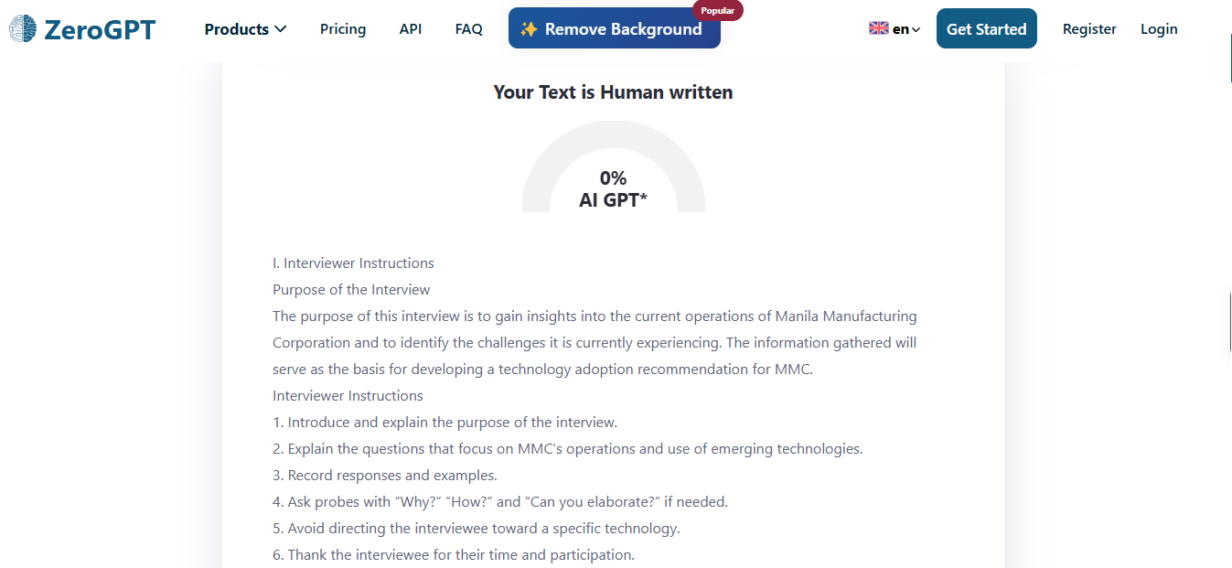
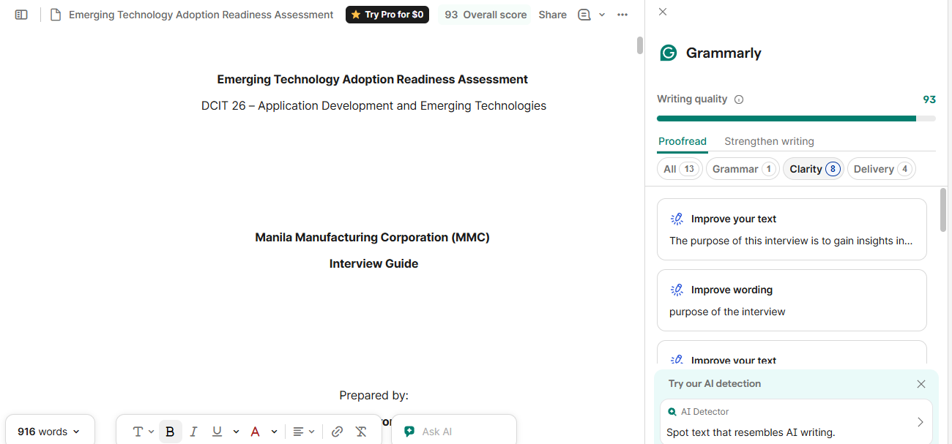
Note: I didn’t include my Front Page and Lines, only sections 1 and 3.

Rubric for Evaluation:
Criteria | Excellent | Good | Satisfactory | Needs Improvement | Score
Completeness of Sections | All 9 sections complete and well-organized | 7-8 sections complete | 5-6 sections complete | Less than 5 sections | /15
Question Quality | Questions are clear, relevant, and probing | Most questions clear and relevant | Some questions unclear or irrelevant | Many questions unclear or irrelevant | /15
Coverage | ALL emerging  technologies  covered  thoroughly | Most  technologies  covered | Some  technologies  covered | Few  technologies  covered | /25
Alignment with  Scenario | Questions perfectly match  the MMC  scenario | Questions  mostly match  the scenario | Some questions  match the  scenario | Questions do not  match the  scenario | /10
Open-Ended  Questions | Excellent mix with effective probes | Good mix with  some probes | Some open-  ended  questions | Few open-ended  questions | /10
Professional Format | Very professional,  clean, and  organized | Professional  with minor  issues | Somewhat  professional | Disorganized or  messy | /15
Practicality | Questions are  practical and  usable | Most questions  are practical | Some questions  are practical | Questions are  impractical | /10
TOTAL SCORE: _____ / 100

